Utopia API Application Form
* 必填
* 灰色字體是提醒或範例，填寫時請將您的資料改成黑色字體
Utopia Application Form (Rev 0.1)
* Applicant | Marcos.Ho | * Request Date | 2016/3/3
* Chip Name | Maserati | * Customer Name /Develop Name | SW3
* Module | PQ | * Please select below items:  - Android□Supernova □Mboot  □Others
*申請的API :
1.[drvPQ_cus.h] - MDrv_PQ_LoadFilmModeTable
2. [drvPQ_cus.h] -MDrv_PQ_LoadDynamicContrastTable
3. [drvPQ_cus.h] -MDrv_PQ_LoadNRTable
4. [drvPQ_cus.h] -MDrv_PQ_LoadMPEGNRTable
5. [drvPQ_cus.h] -MDrv_PQ_Load_ULTRACLEAR_Table
6. [drvPQ_cus.h] -MDrv_PQ_Load_XVYCC_Table
7. [drvPQ_cus.h] -MDrv_PQ_GRULE_Get_Support_Status
8. [drvPQ_cus.h] -MDrv_PQ_SetMemFormat
9. [drvPQ_cus.h] -MDrv_PQ_Set_DisplayType
10. [drvPQ_cus.h] -MDrv_PQ_LoadPTPTable
11. [drvPQ_cus.h] -MDrv_PQ_Check_PointToPoint_Condition
12. [drvPQ_cus.h] -MDrv_PQ_SetPostCCSOnOff
13. [drvPQ_cus.h] -MDrv_PQ_AdaptiveTuning
14. [drvPQ_cus.h] -MDrv_PQ_FilmMode_AnyCandence_Enable
15. [drvPQ_cus.h] -MDrv_BW_LoadTableByContext
16. [drvPQ_cus.h] -MDrv_BW_LoadInitTable
17. [drvPQ_cus.h] -MDrv_PQ_SetH264_OnOff
18. [drvPQ_cus.h] -MDrv_PQ_SetG3D_OnOff
19. [drvPQ_cus.h] -MDrv_PQ_SetMVC4kx1k_OnOff
20. [drvPQ_cus.h] -MDrv_PQ_SetNetworkMM_OnOff
21. [drvPQ_cus.h] -MDrv_PQ_SetMM_OnOff
22. [drvPQ_cus.h] -MDrv_PQ_SetRmvb_OnOff
23. [drvPQ_cus.h] -MDrv_PQ_SetVIPBypass_OnOff
24. [drvPQ_cus.h] -MDrv_PQ_SetPeaking_OnOff
25. [drvPQ_cus.h] -MDrv_PQ_SetFakeOutEnable
26. [drvPQ_cus.h] -MDrv_PQ_ReduceBW_ForOSD
27. [drvPQ_cus.h] -MDrv_BW_resetToDefault
*申請原由 :
1. drvPQ_cus.h 並沒有被追蹤再one utopia 故提出申請.

Application Flow
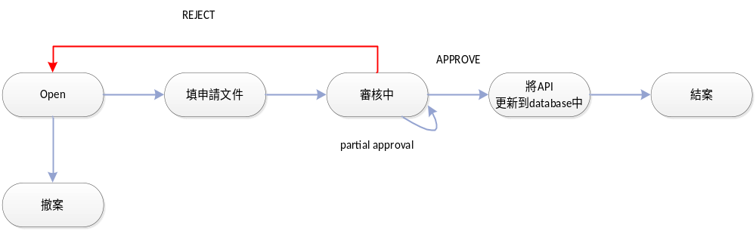

申請流程 :
Step1. 填寫申請文件並寄出
I.E- mail的格式
主旨: [OneUtopia] [Chip Name] [Module] API Application
Ex: [OneUtopia] Manhattan audio API Application

II.mail loop下面人員
收件者 :cc.chen@mstarsemi.com
副本 :dean.tseng@mstarsemi.com;;matt.sung@mstarsemi.com;kilroy.tseng@mstarsemi.com;luke.chiang@mstarsemi.com

III.如果有新增的API請在mail中提供API Specification
API Specification Sample參考:


Step2.審核中
等待CC.chen審核

Step3. 將API更新到database中
當收到APPROVE後 我方會將會更新OneUtopia的database

Step4.結案
在下次utopia的release時
可以看到申請的API已經被APPROVE

